Virtual Fashion Assistance – Look at images and what category that a person is wearing

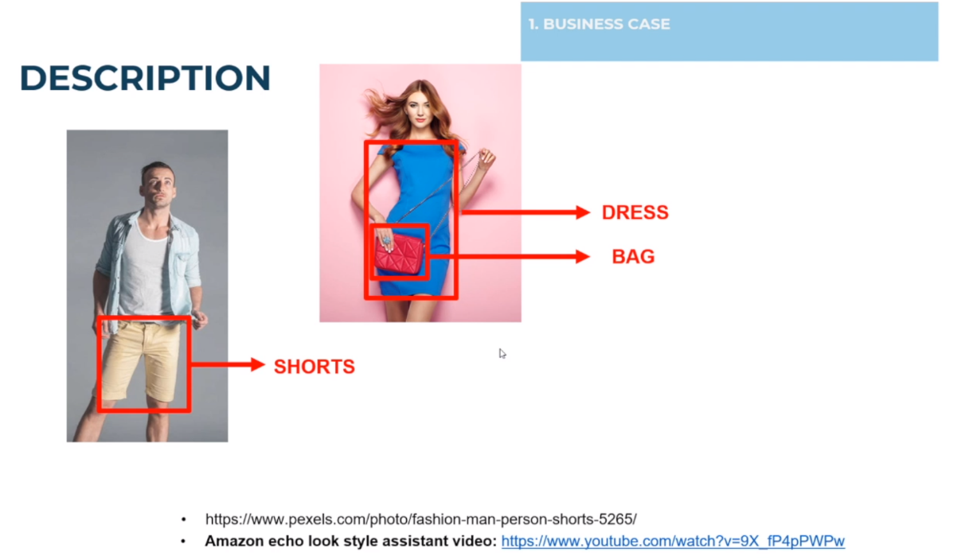Datasets-Bags, Shoes, Shirts. Use Deep learning Algorithm

We can do targeted marketing for this particular customer.

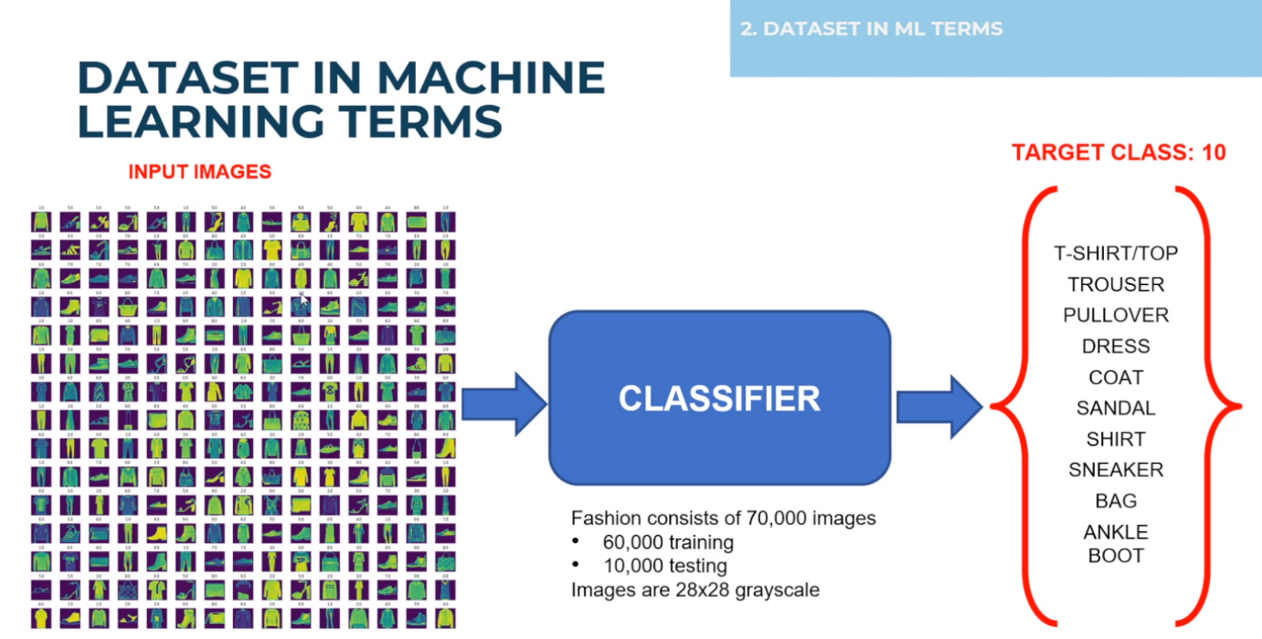Amazon Echo Look Style Assistant – Similar to it.

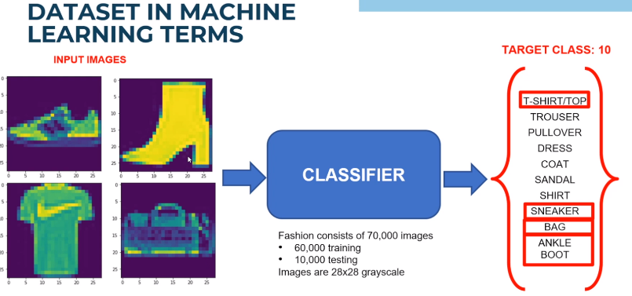Deep learning network to look at images and see if it can be categorized into their respective classes.

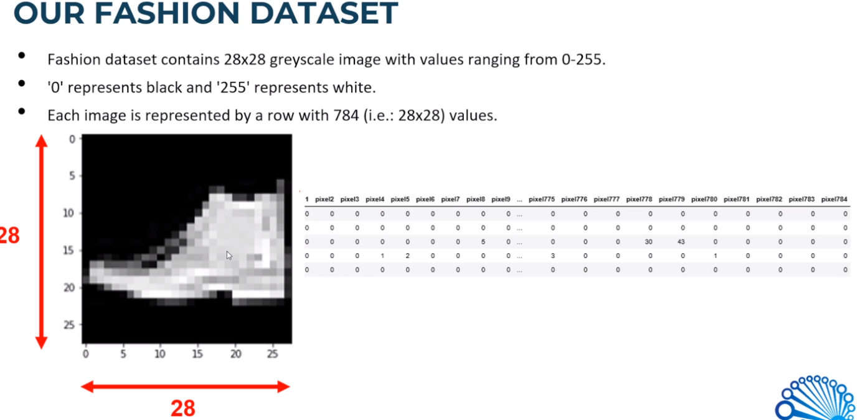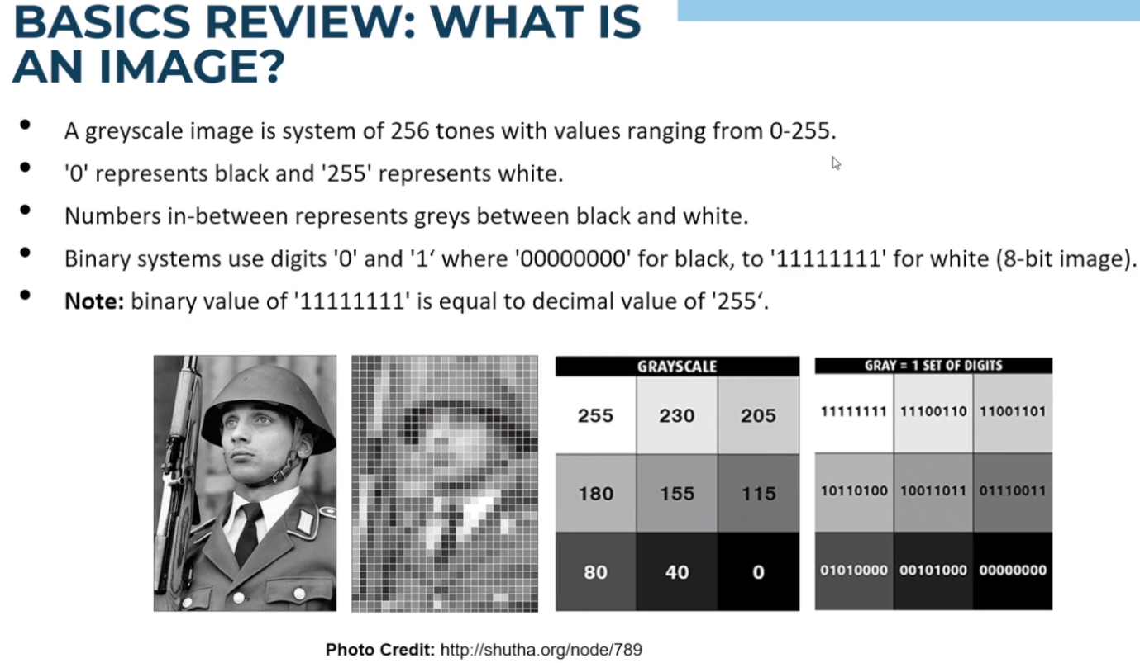28 pix x 28 pix grey scale image. Stored within the computer with a bunch of numbers

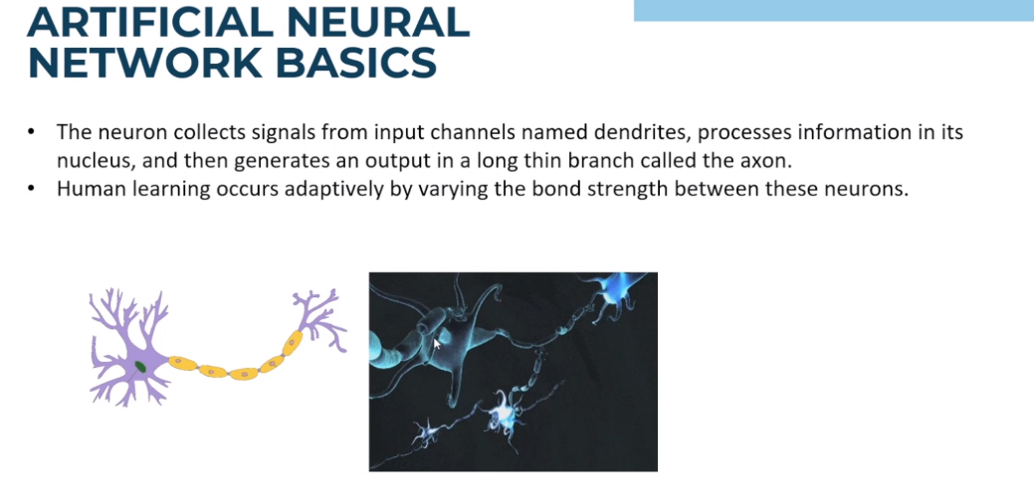How can Human Learn in General?

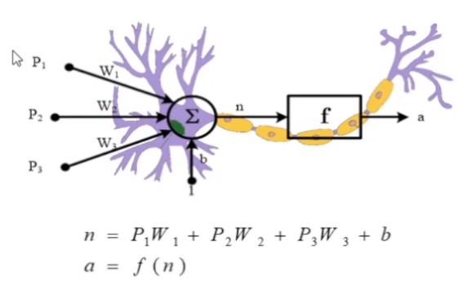Neurons collect data, process info in the Nucleus, and generate learning in our Axons.

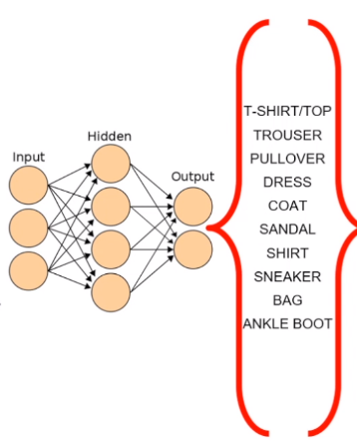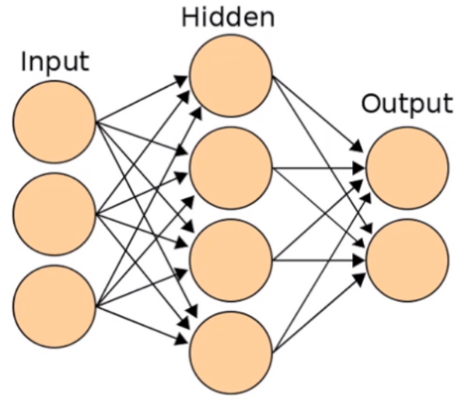 Activation Function – Sigmoid or Rectifier function. We will be changing the weights value to learn a specific Pattern.

We take 28x28 and use it as an input and train the network. Cannot treat network and images in general. Images, We need to preserve all the spatial dependence between the pixels, All the pixels are independent.

Hence, we need to perform convolution before we feed into the network. Run a convolution layer/Feature detector.

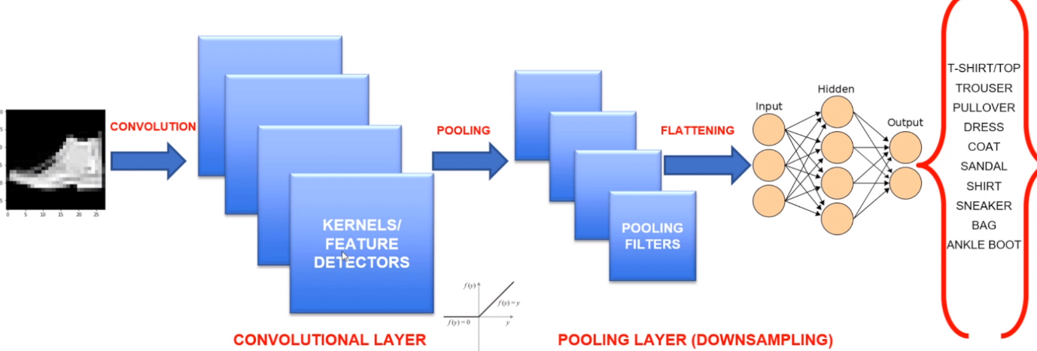Use the feature and perform Pooling then we flatten and put into our neural network

Feature Detector.

* Convolution use a kernel matrix to scan a given image and apply a filter to obtain a certain effect.
* An Image Kernel is a matrix used to apply effects such as blurring and shaping
* Kernels are used in machine learning for feature extraction to select most important pixels of an image.
* 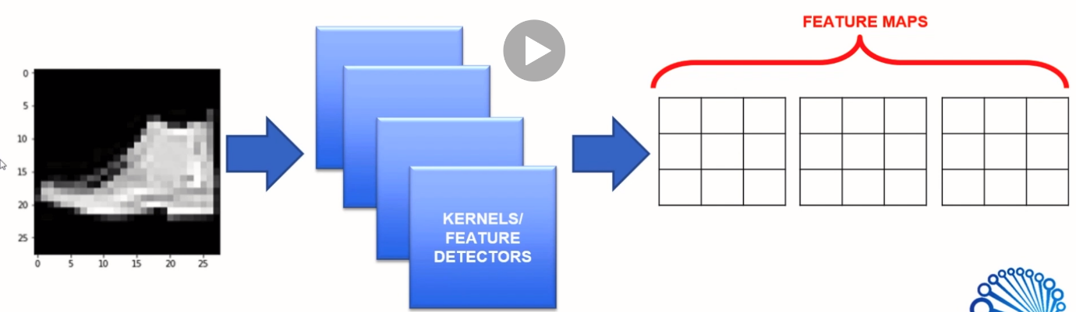Convolution preserves the spatial relationship between pixels

Feature Maps are outputs of running Feature Detectors on the Inputs.

How many pixels are we shifting, called Stride

setosa.io/ev/image-kernels/

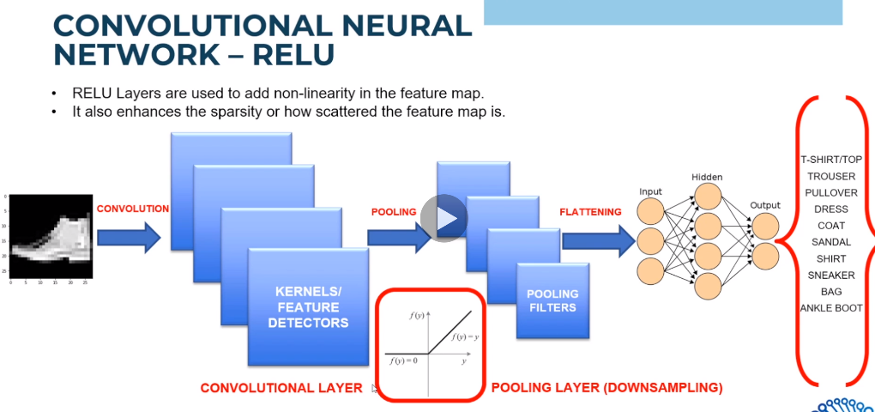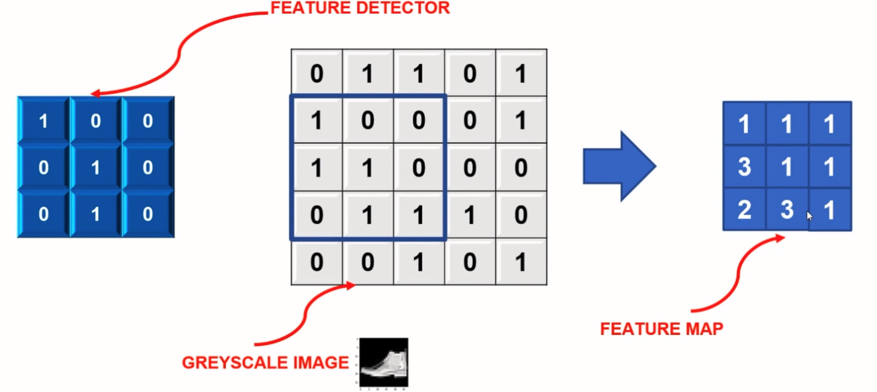Pooling-Recitified Linear Layer

Any Number that is negative, we shut it down to Zero. We don’t need any valleys below zero we just kill it by setting it to zero

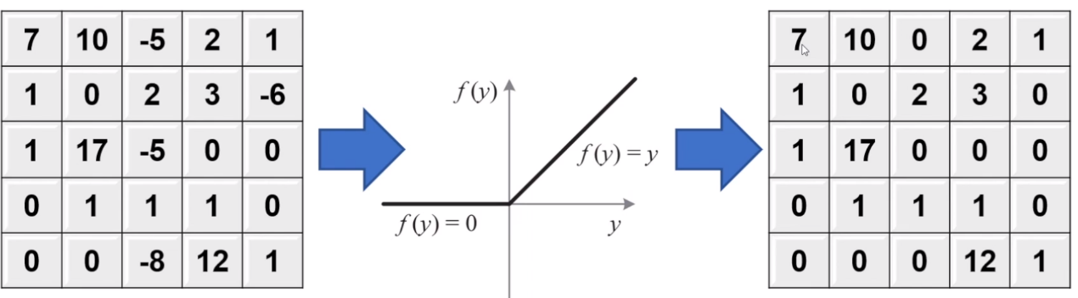

We don’t apply Sigmoid function because we need to keep the gradient. Gradient of Relu does not vanish as we increase X compared to sigmoid function. We want to preserve our slope. We don’t want the gradient to saturate.

Max pooling and Flattening

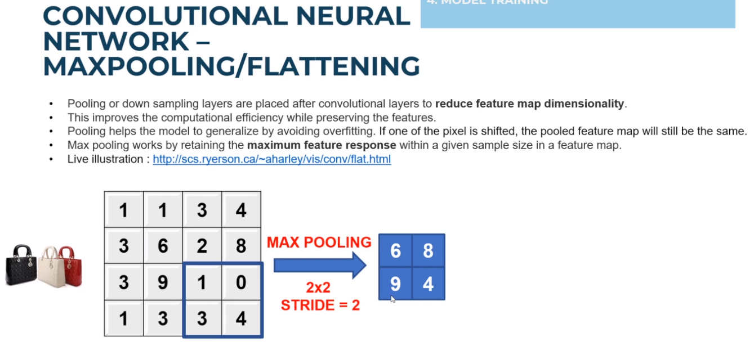Max Pooling – we take 4x4 image and boiling it down to 2x2 while preserving the features. With 2x2 filter, with stride of 2, and select the maximum value. Reduce the Map’s dimensionality. Preserve the pre-dominant features.

Second benefit is that it helps the model to Generalise. If we look at bags that is tilted to the right, left, top view, transformed images. We can do so by doing Max Pooling. The max value is gonna be actually be the same. Regardless of if the value is shifted by 1 or 2 pixels

Flattening. Take the 28x28 image and make it into 1d array and feed it into our network

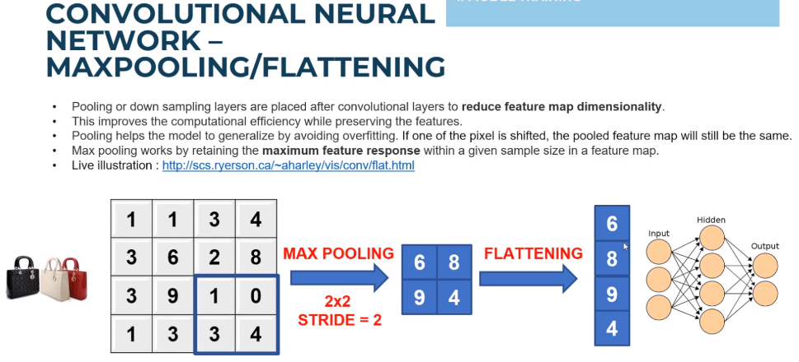

Improving the Model

Increase the Kernels

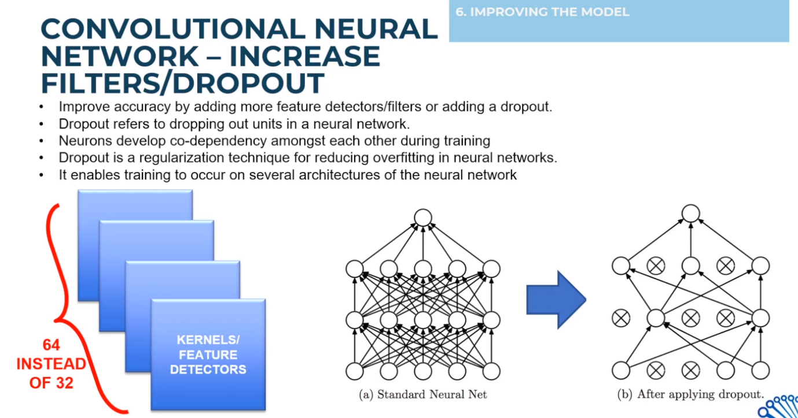Drop outs- Keep adjusting the weights, Dropping some neurons while training your architecture.

